**ACID RAIN**

*‘Acid rain’*, or more accurately ‘*acid precipitation’*, is the term used for describing rainfall with a pH level lower than 5.6. This type of pollution is a matter of great debate currently due to the potential of its causing environmental damages all across the world. For the last decade or so acid rain has caused destruction to hundreds of lakes and streams in many parts of the world, including the US, Canada, and Europe. **Scientists first discovered acid rain in 1852, when the English chemist Robert Agnus invented the term**.  Acid rain, one of the most important environmental problems of all, cannot be seen.

Acid Rain primarily means the deposition of acidic elements in the forms of precipitation, which can be snow, rain, dew or fog. Rain is slightly acidic because it contains dissolved carbon dioxide (CO2). Sulphur dioxide (SO2) and Nitrogen oxides (NOx) which are normally present in the air. Acid rain contains more acidity than the normal value because of presence of acid ions due to the dissolution of these gases present in higher concentration. Acid rain, therefore, is the direct consequence of air pollution caused by gaseous emissions from industrial sources, burning of fuels (thermal plants, chimneys of brick-kilns or sugar mills.) and vehicular emissions. It is not necessary that acid rain will occur locally near the sources of air pollution. Due to the movement of air, acid rain may occur for away from the source. For instance, U.K. contributes 26% of the acidic sulphur deposited in the Netherlands, 23% in Norway and 12% in Sweden. Acid emissions arise naturally from volcanoes, forest fires and biological decomposition, especially in the oceans. But their contribution to acid rain are SO2, NOx and to a lesser extent CO2 and hydrocarbon gas.

SO2 pollutions are mostly contributed by thermal power plants, refineries industry and NOx form road transport, power stations and industry. The acid gas concentrations in the air will vary according to location, time and weather conditions.

**7.6.1 ACID RAIN: TYPES OF ACID DEPOSITION**

There are two types of Acid Deposition, one is wet and the other is dry. Wet deposition is the one, which involves Acid Rain or snow or dew whereas Dry deposition is when the particles such as polluting gases, dust particles and gaseous elements are just absorbed by the surface of the Earth or the plant bodies. They are not converted into acids until and unless they are in contact with water. In case of Wet deposition the acids are removed from the atmospheric air and are deposited on the surface of the earth.

**7.6.2 CAUSE OF ACID RAIN**

Human activities are the main cause of acid rain. Over the past few decades, humans have released so many different chemicals into the air that they have changed the mix of gases in the atmosphere. Power plants release the majority of sulfur dioxide and much of the nitrogen oxides when they burn [fossil fuels](http://www.epa.gov/acidrain/education/site_students/glossary.html#fos), such as coal, to produce electricity. In addition, the [exhaust](http://www.epa.gov/acidrain/education/site_students/glossary.html#exh) from cars, trucks, and buses releases nitrogen oxides and sulfur dioxide into the air. These pollutants cause acid rain.

Acid rain is caused by a chemical reaction that begins when [compounds](http://www.epa.gov/acidrain/education/site_students/glossary.html#com) like sulfur dioxide and nitrogen oxides are released into the air. These substances can rise very high into the atmosphere, where they mix and react with water, oxygen, and other chemicals to form more [acidic pollutants](http://www.epa.gov/acidrain/education/site_students/glossary.html#aci) such as sulphuric acid, nitric acid etc., known as acid rain. Sulfur dioxide and nitrogen oxides dissolve very easily in water and can be carried very far by the wind. As a result, the two compounds can travel long distances where they become part of the rain, sleet, snow, and fog that we experience on certain days.

The chemical reactions involved during the process of acid rain are as follows:

**H2O + CO2  H2CO3**

**2 SO2 + O2 2SO3**

**2NO + O2 2NO2**

**SO3 + H2O H2SO4**

**2NO2 + H2O HNO2 + HNO3**

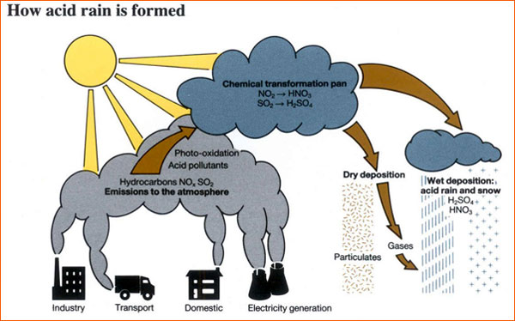

**Figure 7.4:** **Acid rain formation process**

**7.6.3 EFFECTS OF ACID RAIN**

The most important effects are as follows:

* **Effects on materials and buildings:** Acid rain and the dry deposition of acidic particles contribute to the corrosion of metals (such as bronze) and the deterioration of paint and stone (such as marble and limestone). These effects seriously reduce the value to society of buildings, bridges, cultural objects (such as statues, monuments, and tombstones), and cars. Dry deposition of acidic compounds can also dirty buildings and other structures, leading to increased maintenance costs.
* **Effects on water bodies:** The ecological effects of acid rain are most clearly seen in the aquatic or water environments such as streams, lakes, and marshes. Acid rain flows into streams, lakes, and marshes after falling on forests, fields, buildings, and roads. Acid rain also falls directly on aquatic habitats. Most lakes and streams have a pH between 6 and 8, although some lakes are naturally acidic even without the effects of acid rain. Acid rain primarily affects sensitive bodies of water, which are located in watersheds whose soils have a limited ability to neutralize acidic compounds (called "buffering capacity"). Lakes and streams become acidic (pH value goes down) when the water itself and its surrounding soil cannot buffer the acid rain enough to neutralize it. In areas where buffering capacity is low, acid rain also releases aluminum from soils into lakes and streams.
* **Effects of acid rain on plant life:** Acid rain seeps into the earth and poisons plants and trees by dissolving toxic substances in the soil, such as aluminum, which get absorbed by the roots. Acid rain also dissolves the beneficial minerals and nutrients in the soil, which are then washed away before the plants and trees have a chance of using them in order to grow.

When there is frequent acid rain, it corrodes the waxy protective coating of the leaves. When this protective coating on the leaves is lost, it results in making the plant susceptible to disease. When the leaves are damaged, the plant loses its ability to produce sufficient amounts of nutrition for it to stay healthy. Once weakened, the plant becomes vulnerable to the cold weather, insects, and disease, which can lead to its death.

* **Effects of acid rain on aquatic life:** Apart from plants, acid rain also affects aquatic organisms adversely. A high amount of sulfuric acid interferes with the ability of fish to take in nutrients, salt, and oxygen. As far as freshwater fish is concerned, in order for them to stay alive they need to have the ability of maintaining a balance between the minerals and salts in their tissues. The molecules of acid result in mucus forming in their gills, which prevents them from absorbing oxygen in adequate amounts. The acidity, which reduces the pH level, causes the imbalance of salt in the tissues of fish.  
  Moreover, this change in the pH level also impairs the some of the fish’s ability to maintain their calcium levels. This impairs reproduction the ability of the fish, because the eggs become too weak or brittle. Lack of calcium also causes deformed bones and

weakened spines.

* **Effects of acid rain on humans:** Most of all, acid rain affects human health adversely. It has the ability of harming us via the atmosphere as well as the soil where the food we eat is grown. Acid rain results in toxic metals breaking loose from the chemical compounds they occur in naturally. While toxic metals may be dangerous, but as long as they exist in combination with other elements, they are not harmful. Once acid rain causes these toxic metals to be released they can infiltrate into the drinking water, and the animals or crops that humans use as sources of food. This contaminated food can damage the nerves in children, or result in severe brain damage, or even death.

**7.6.4 PREVENTION MEASURES OF ACID RAIN**

1. **Reduce emissions:**

* Burning fossil fuels is still one of the cheapest ways to produce electricity so people are now researching new ways to burn fuel which don't produce so much pollution.
* Sulphur can also be 'washed' out of smoke by spraying a mixture of water and powdered limestone into the smokestack.
* Cars are now fitted with catalytic converters which remove three dangerous chemicals from exhaust gases.

1. **Find alternative sources of energy:**

* Governments need to invest in researching different ways to produce energy.
* Clean fuel like hydrogen, solar energy, wind energy should be used.

1. **Conserving Resources**

* Greater subsidies of public transport by the government to encourage people to use public transport rather than always travelling by car.
* Every individual can make an effort to save energy by switching off lights when they are not being used and using energy-saving appliances - when less electricity is being used, pollution from power plants decreases.
* Walking, cycling and sharing cars all reduce the pollution from vehicles.

**7.7 OZONE LAYER DEPLETION**

The distribution of ozone in the stratosphere is a function of altitude, latitude and season. It is determined by photochemical and transport processes. The ozone layer is located between 10 and 50 km above the Earth's surface and contains 90% of all stratospheric ozone. Ozone is formed when oxygen molecules absorb ultraviolet photons and undergo a chemical reaction known as photo dissociation or photolysis, where a single molecule of oxygen breaks down to two oxygen atoms. The free oxygen atom (O), then combines with an oxygen molecule (O2) and forms a molecule of ozone (O3). The ozone molecules in turn absorb ultraviolet rays between 310 to 200 nm wavelengths and thereby prevent these harmful radiations from entering the Earth's atmosphere. In the process, ozone molecules split up into a molecule of oxygen and an oxygen atom. The oxygen atom (O) again combines with the oxygen molecule (O2) to regenerate an ozone (O3) molecule. Thus, the total amount of ozone is maintained by this continuous process

of destruction and regeneration.   
 **O2 + hυ O + O**

**O2 + O + M O3 + M**

**O3 + hυ O2 + O**

The ozone layer is essential to life on earth, as it absorbs harmful ultraviolet-B radiation from the sun. In recent years the thickness of this layer has been decreasing, leading in extreme cases to holes in the layer. Measurements carried out in the Antarctic have shown that at certain times, more than 95% of the ozone concentrations found at altitudes of between 15 and 20 km and more than 50% of total ozone are destroyed, with reductions being most pronounced during winter and in early spring. Natural phenomena, such as sun-spots and stratospheric winds, also decrease stratospheric ozone levels, but typically not by more than 1-2%.

Ozone layer depletion first captured the attention of the whole world in the later half of 1970 and since then, many discussions and researches have been carried out to find out the possible effects and the causes of ozone depletion.

**7.7.1 CAUSES OF OZONE DEPLETION**

The cause of ozone depletion is the increase in the level of free radicals such as hydroxyl radicals, nitric oxide radicals and atomic chlorine and bromine. *The most important compound, which accounts for almost 80% of the total depletion of ozone in the stratosphere are chlorofluorocarbons (CFC) such as CFC-11, CFC-12*. Other compounds which are responsible for ozone layer depletion are halons (halons re bromo-chloro-fluorocarbons or bromo-fluorocarbons that are widely used in fire extinguishers) and methyl chloroform, methyl bromide, carbontetrachloride solvents produced from industrial sources. [Chlorofluorocarbons](http://www.ace.mmu.ac.uk/eae/ozone_depletion/older/CFCs.html) are not "washed" back to Earth by rain or destroyed in reactions with other chemicals. They simply do not break down in the lower atmosphere and they can remain in the atmosphere from 20 to 120 years or more. As a consequence of their relative stability, CFCs are instead transported into the [stratosphere](http://www.ace.mmu.ac.uk/eae/ozone_depletion/older/Stratosphere.html) where they are eventually broken down by [ultraviolet](http://www.ace.mmu.ac.uk/eae/ozone_depletion/older/Ultraviolet_Radiation.html) (UV) rays from the [Sun](http://www.ace.mmu.ac.uk/eae/ozone_depletion/older/Sun.html), releasing free chlorine. A free chlorine atom reacts with an ozone molecule (O3) and forms chlorine monoxide (ClO) and a molecule of oxygen. Now chlorine monoxide reacts with an ozone molecule to form a chlorine atom and two molecules of oxygen. The free chlorine molecule again reacts with ozone to form chlorine monoxide. The process continues and the result is the reduction or depletion of ozone in the stratosphere. Once in the stratosphere, every

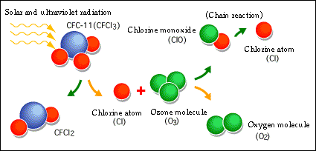chlorine atom can destroy up to 100 000 ozone molecules.

**Figure 7.5 :** **Mechanism of ozone layer destruction by CFC in stratosphere**

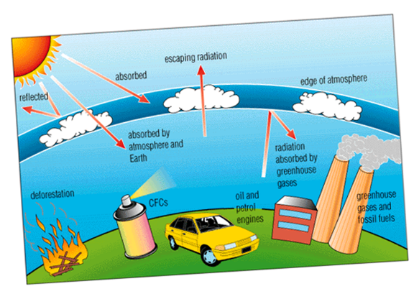

**Figure 7.6:** **Human activities which cause depletion of ozone layer**

**7.7.2 EFFECTS OF OZONE LAYER DEPLETION**

The main potential consequences of this ozone depletion are:

* **Increase in UV-B radiation at ground level:** a one percent loss of ozone leads to a two percent increase in UV radiation. Continuous exposure to UV radiation affects humans, and can lead to skin problems (ageing, cancer), depression of the immune system, and corneal cataracts (an eye disease that often leads to blindness). Increased UV radiation may also lead to a massive die-off of photoplancton (a CO2 "sink") and therefore to increased global warming.
* **Reduction of the ozone greenhouse effect:** ozone is considered to be a greenhouse gas. A depleted ozone layer may partially dampen the greenhouse effect. Therefore efforts to tackle ozone depletion may result in increased global warming.
* it can affect animals and plants as well. It can affect important food crops like rice by adversely affecting cyanobacteria, which helps them absorb and utilize nitrogen properly. Phytoplankton, an important component of the marine food chain, can also be affected by ozone depletion. Studies in this regard have shown that ultraviolet rays can influence the survival rates of these microscopic organisms by affecting their orientation and mobility.
* Disturbance of the thermal structure of the atmosphere, probably resulting in changes in atmospheric circulation.
* Changes in the tropospheric ozone and in the oxidizing capacity of the troposphere.

International targets for the reduction of ozone depleting substances have resulted in the almost complete phasing out of CFCs, halons and carbon tetrachloride. Methyl chloroform and methyl bromide will be phased out by 2005 and HCFC by 2040. The increasing concern for the causes and effects of ozone depletion led to the adoption of the Montreal Protocol, in the year 1987, in order to reduce and control the industrial emission of chlorofluorocarbons. International agreements have succeeded to a great extent in reducing the emission of these compounds, however, more cooperation and understanding among all the countries of the world is required to mitigate the problem.

**7.7.3 The Antarctic “Ozone Hole”: A Case study**

The severe depletion of stratospheric ozone that has occurred every year since the 1980s during Antarctic springtime is known as the “ozone hole.” This hole is created by the reactive gases containing chlorine and bromine that destroy ozone. The ozone hole was discovered in the early 1980s by researchers making ground-based measurements of the ozone above this region. The depletion of the Antarctic ozone layer occurs because of the interactions of ozone-depleting substances in the unique weather conditions that exist only in this region. The very low temperatures of the Antarctic stratosphere create ice clouds called polar stratospheric clouds (PSCs). Special reactions that occur during springtime on these clouds, along with the relative isolation of polar stratospheric air, allow chlorine and bromine reactions to produce the ozone hole. Amounts of ozone are often described in terms of the thickness of ozone in a column of air that stretches from the Earth’s surface to the top of the atmosphere. *The most common measurement of total ozone values in the column are called Dobson units (DU).* One DU is equal to the number of molecules of ozone that would be needed to create a layer of pure ozone 0.01 millimeter thick. Typical amounts vary between 200 and 500 DU around the world. The total ozone value of the ozone hole is only 100 DU. This is equivalent to a layer of pure ozone gas on Earth’s surface having a thickness of only 1 millimeter (less than one sixteenth of an inch).